Suggestions on how to get Excellence in 3.8 Time Series
- Discuss the context. This MUST be relevant to your question. You MUST integrate statistical and contextual knowledge at all appropriate components of the PPDAC. In particular for excellence, discuss the context in the conclusion and state implications for the future. The future for the context and/or the future for further investigation.
- Discuss the types of model. An additive time series model can use the trend + seasonality if the seasonality is constant. If the seasonality is variable then a multiplicative time series model is more appropriate. (though we do not use these at our level)
- Discuss the smoothing model. LOWESS (locally weighted regression scatterplot smoothing) uses an exponential model and weights the closer data values more heavily than data values from the distant past or distant future.
- Discuss the prediction model. Holt-Winters model assumes the seasonal pattern is relatively constant over the time period. If a model shows changes in the seasonal pattern then this is a potential problem with the model, especially if long term predictions are made.
- Discuss how the smoothing model can influence the prediction model. The trend line can be influenced by the position in the seasonal cycle endpoint. If the last data point is where the seasonality is down, the trend drops, and the prediction is low, and vice versa (as seen below). A way to combat this is to remove the last data points so the last point is as neutral as possible, and when we discuss the trend line we should steer clear of the end points of the data by half of the seasonal cycle.
Here are the three situations together:
Trend drops | Trend Flat | Trend Rising
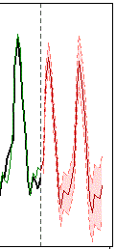 | 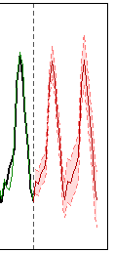 | 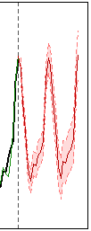
- Test the robustness of the prediction model. Remove the last few pieces of data and then make a prediction in the normal way. Now we have predicted and actual data to compare OR have a look on the internet for the actual source of the data… there may be more up to date data that you can compare.
- Investigate links between variables. YOU MUST HAVE A CLEAR REASON TO DO THIS. For example, comparing the actual population data next to the grocery sales data for the same time period shows another possible explanation for the upward trend.
- Combine variables to create a new variable. YOU MUST HAVE A CLEAR REASON TO DO THIS. I can’t think of an example, can you?
- Investigate additional time series data. YOU MUST HAVE A CLEAR REASON TO DO THIS. If you have time, and a reason, then you can look at another related data set to help explain what is going on in the original data.
Thanks to L Barnett for these suggestions.

